Read the following article by Ranganathan, P. (2021) ‘An introduction to statistics: choosing the correct statistical test’, Indian Journal of Critical Care Medicine, 25(Suppl 2), pp. S184–S186. and answer the questions below:

What are the type of data being measured?
In the report there are no specifics. It talks about how you should consider different types of data:
Categorical, numerical
Then speaks about if it is normally distributed or not.

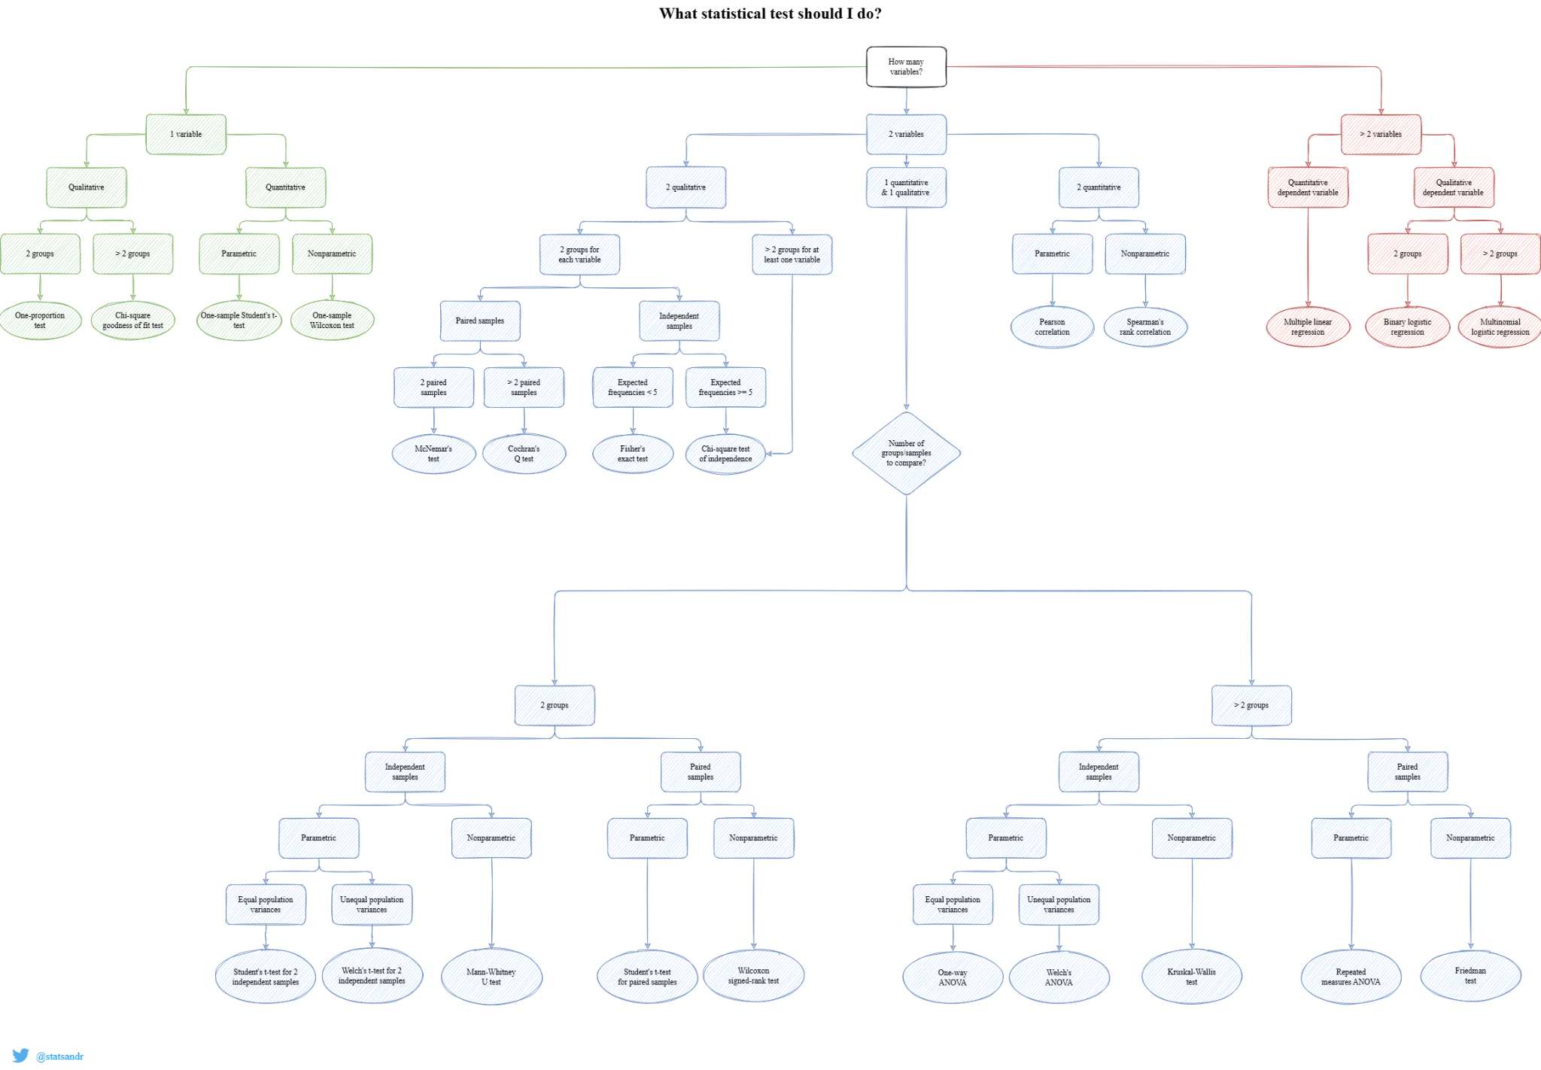
(Soetewey, 2021)

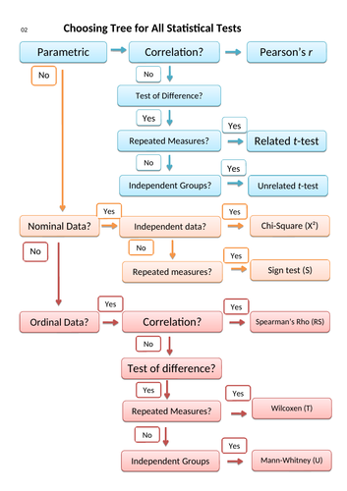
(Blonde_Pretzel, 2018)

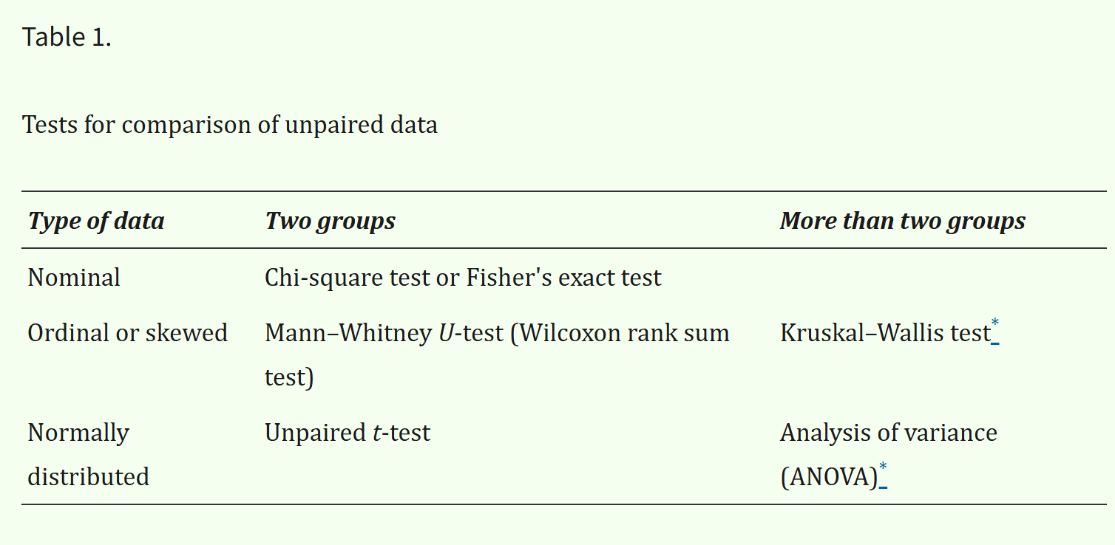
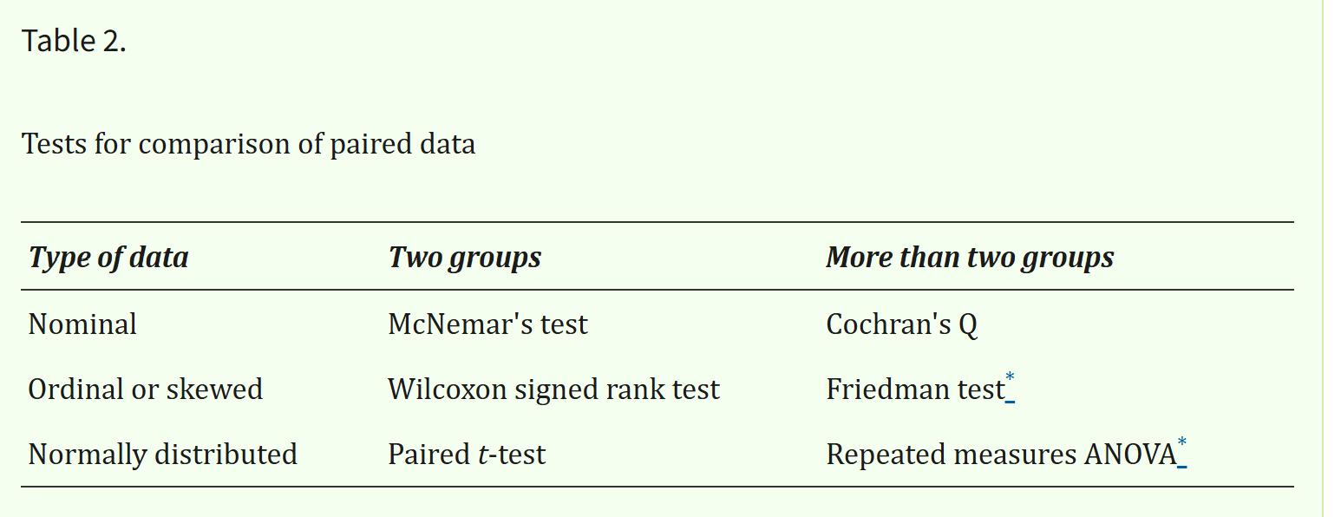

What are tests for association between variables?

Correlation
Normally distributed data: Pearson’s Correlation coefficient
One or both data squewed: Spearman’s/Kendall’s correlation coefficient
Nominal data: Chi-square test; odds ratio or relative risk

Regression
Continuous outcome: Linear regression analysis
Categorical outcome: Logistic regression analysis

What are the differences between paired and unpaired data?
Data collected from the same individual/item/area, e.g. over time, after and before treatment, left and right side, possibly twins! Are paired.

Data collected from different samples or populations are unpaired. E.g. men and women, sick and not sick, old and young, different materials or shapes.

Using this sales forecasting dataset, perform the following activities:

Conduct a Paired t-test for customers who purchased from both Technology and Furniture categories to assess if there is a significant difference in their average spending between these two categories
H₀ Furniture = Technology
H_{a} Furniture ≠ Technology
First the data was cleaned to only the significant variables.
Then the additional Office Supplies category was removed.
Reducing to 3891 observations and 3 variables.

library(readr)
library(dplyr)

train <- read_csv("seminar/train.csv")
View(train)

d1 <- train

d2 <- train %>%
select(`Customer ID`, Category, Sales)

This data was inspected
boxplot(Sales ~ Category,
data = d2,
main = "Category Vs Sales",
xlab = "Category",
ylab = "Sales",
col = "lightblue")

table(d2$Category)

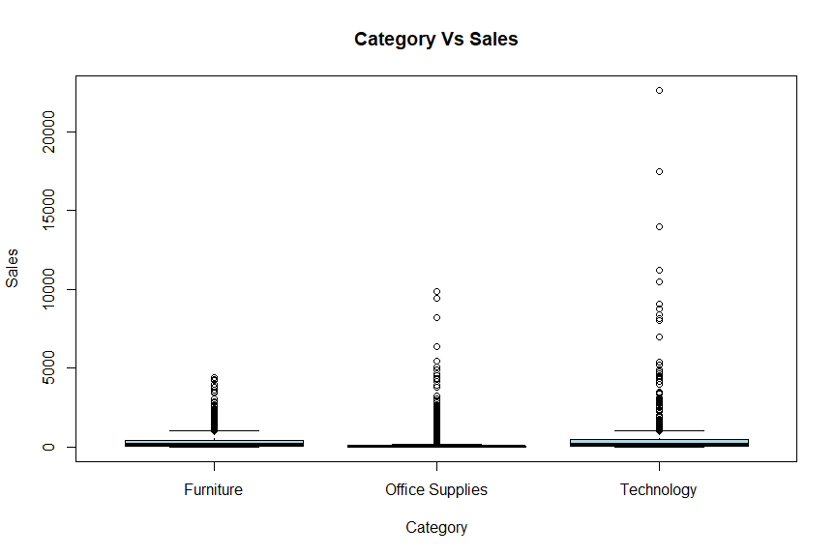
Furniture Office Supplies Technology
2078 5909 1813

Note the right-tailed data with multiple potential outliers.

Next the data was simplified further to only include furniture and technology.

d3 <- d2[d2$Category != "Office Supplies", ]

aggregate(Sales ~ Category, data = d3, summary)

Category Sales.Min. Sales.1st Qu. Sales.Median Sales.Mean Sales.3rd Qu. Sales.Max.
1 Furniture 1.8920 47.1900 182.6100 350.6538 435.2370 4416.1740
2 Technology 0.9900 67.9800 167.9440 456.4015 453.5760 22638.4800

Reducing the data to 3891 observations and 3 variables

At this point it is notable that the mean varies more from the median in the Technology category than the furniture category. This is evidenced in the earlier boxplot.

Next the data was formatted so that customer ids were paired with total number of technology and furniture sales and nill values were checked.
This decision was made as the instructions were to form paired tests. There are a similar number of observations for each type of sale. However a follow up test that compares individual sales was also created (see below).
d4 <- d3 |>
group_by(`Customer ID`) |>
summarise(
`Furniture sales total` = sum(Sales[Category == "Furniture"], na.rm = TRUE),
`Technology sales total` = sum(Sales[Category == "Technology"], na.rm = TRUE)
)

colSums(is.na(d4))
This reduced the data to 774 observations and 3 variables with no reported empty values, however 0 values were present in the data.
I did not catch this the first time.
More code added to filter this

#check fir empty values
colSums(is.na(d4))

# Check zero values
sum(d4$`Furniture sales total` == 0, na.rm = TRUE)
sum(d4$`Technology sales total` == 0, na.rm = TRUE)

#remove zero values
d5 <- d4 |>
dplyr::filter(
`Furniture sales total` != 0,
`Technology sales total` != 0
)

> sum(d4$`Furniture sales total` == 0, na.rm = TRUE)
[1] 69
> sum(d4$`Technology sales total` == 0, na.rm = TRUE)
[1] 90
Reduced data to 615 observations and 3 variables

#boxplot new dataset - obvious outliers in technology - right tailed high number of outliers
boxplot(
d5$`Furniture sales total`,
d5$`Technology sales total`,
names = c("Furniture", "Technology"),
main = "Furniture vs Technology",
xlab = "Category",
ylab = "Sales total",
col = c("orange", "lightblue")
)
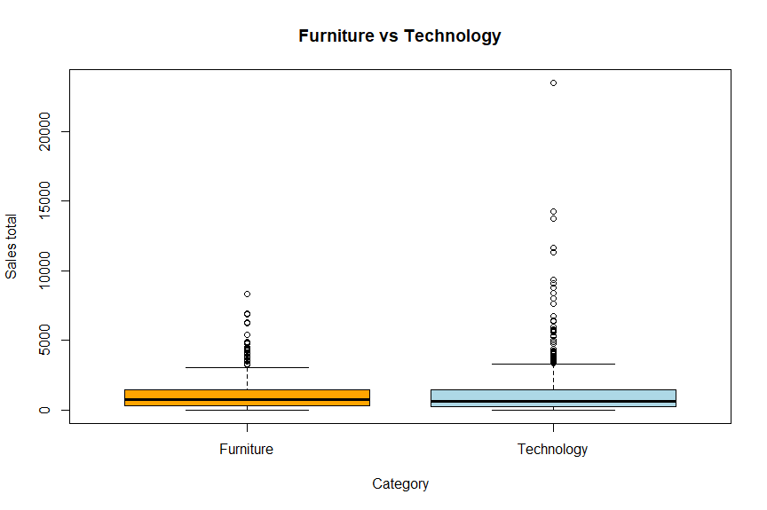
The observed boxplot makes it hard to draw conclusions, due to the long right-tailed data.

#compaire - !! note high difference between median and mean
summary(d5[, c("Furniture sales total", "Technology sales total")])

Furniture sales total Technology sales total
Min. : 4.928 Min. : 1.584
1st Qu.: 310.437 1st Qu.: 229.980
Median : 763.920 Median : 608.430
Mean :1088.391 Mean : 1224.643
3rd Qu.:1432.448 3rd Qu.: 1474.590
Max. :8332.090 Max. :23481.508

A summary of the data shows the high disparity between the median and mean, especially on the technology category, this is inline with the boxplot.

t.test(
d5$`Furniture sales total`,
d5$`Technology sales total`,
paired = TRUE
)

Paired t-test

data: d5$`Furnituresalestotal`andd5$`Technology sales total`
t = -1.5705, df = 614, p-value = 0.1168
alternative hypothesis: true mean difference is not equal to 0
95 percent confidence interval:
-306.62345 34.12048
sample estimates:
mean difference
-136.2515

wilcox.test(
d4$`Furniture sales total`,
d4$`Technology sales total`,
paired = TRUE
)
Wilcoxon signed rank test with continuity correction

data: d5$`Furnituresalestotal`andd5$`Technology sales total`
V = 98749, p-value = 0.3596
alternative hypothesis: true location shift is not equal to 0

Both the paired t-test and the wilcox test (selected as the data is not normally distributed), demonstrate that the null hypothesis should not be rejected.

Remove outliers
As a follow up experiment the outliers were removed to an IQR of 1.5

#create new data set remove outliers - 1.5IQR
Q1_f <- quantile(d5$`Furniture sales total`, 0.25, na.rm = TRUE)
Q3_f <- quantile(d5$`Furniture sales total`, 0.75, na.rm = TRUE)
IQR_f <- IQR(d5$`Furniture sales total`, na.rm = TRUE)

Q1_t <- quantile(d5$`Technology sales total`, 0.25, na.rm = TRUE)
Q3_t <- quantile(d5$`Technology sales total`, 0.75, na.rm = TRUE)
IQR_t <- IQR(d5$`Technology sales total`, na.rm = TRUE)

d6 <- d5[
d5$`Furniture sales total` >= (Q1_f - 1.5 * IQR_f) &
d5$`Furniture sales total` <= (Q3_f + 1.5 * IQR_f) &
d5$`Technology sales total` >= (Q1_t - 1.5 * IQR_t) &
d5$`Technology sales total` <= (Q3_t + 1.5 * IQR_t),
]

#compare
nrow(d5)
nrow(d6)
Data was reduced to 537 observations and 3 variables.

#boxplot new dataset - obvious outliers in technology - less right-tailed data
boxplot(
d6$`Furniture sales total`,
d6$`Technology sales total`,
names = c("Furniture", "Technology"),
main = "Furniture vs Technology",
xlab = "Category",
ylab = "Sales total",
col = c("orange", "lightblue")
)
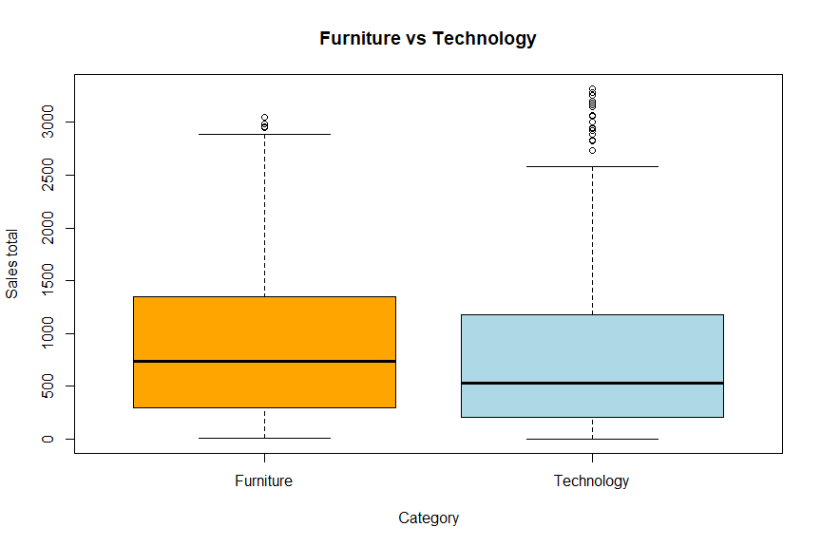
A box plot reveals a clearer trend in the data

summary(d6[, c("Furniture sales total", "Technology sales total")])

Furniture sales total Technology sales total
Min. : 4.928 Min. : 1.584
1st Qu.: 294.705 1st Qu.: 205.964
Median : 741.322 Median : 529.980
Mean : 898.487 Mean : 787.089
3rd Qu.:1348.868 3rd Qu.:1179.744
Max. :3045.824 Max. :3318.680

The summary suggests a trend for higher overall spending per customer on furniture than technology. However it is also worth noting that there are more total sales for furniture than technology, which may be a contributing factor.

t.test(
d6$`Furniture sales total`,
d6$`Technology sales total`,
paired = TRUE
)

Paired t-test

data: d6$`Furnituresalestotal`andd6$`Technology sales total`
t = 2.5195, df = 536, p-value = 0.01204
alternative hypothesis: true mean difference is not equal to 0
95 percent confidence interval:
24.54465 198.25124
sample estimates:
mean difference
111.3979

#wilcox test
# p value low - reject null hypothisis
wilcox.test(
d6$`Furniture sales total`,
d6$`Technology sales total`,
paired = TRUE
)
Wilcoxon signed rank test with continuity correction

data: d6$`Furnituresalestotal`andd6$`Technology sales total`
V = 81632, p-value = 0.008941
alternative hypothesis: true location shift is not equal to 0

T tests and Mann–Whitney U tests confirm this with low p values. Demonstrating how outliers can skew data significantly!

Follow-Up non-paired, total sales for comparison
H₀ Furniture = Technology
H_{a} Furniture ≠ Technology

First the data was cleaned to only the significant variables.
Then the additional Office Supplies category was removed.
Reducing to 3891 observations and 3 variables.

library(readr)
library(dplyr)

train <- read_csv("seminar/train.csv")
View(train)

d1 <- train

#simplify dataset
d2 <- train %>%
select(`Customer ID`, Category, Sales)

# box plot
boxplot(Sales ~ Category,
data = d2,
main = "Category Vs Sales",
xlab = "Category",
ylab = "Sales",
col = "lightblue")

#get values
table(d2$Category)

#remove office supplies
d3 <- d2[d2$Category != "Office Supplies", ]

Then a check for outliers was conducted:

aggregate(Sales ~ Category, data = d3, summary)

#boxplot new dataset - obvious outliers in technology - right tailed
boxplot(Sales ~ Category,
data = d3,
main = "Category Vs Sales",
xlab = "Category",
ylab = "Sales",
col = "lightblue")
Category Sales.Min. Sales.1st Qu. Sales.Median Sales.Mean Sales.3rd Qu. Sales.Max.
1 Furniture 1.8920 47.1900 182.6100 350.6538 435.2370 4416.1740
2 Technology 0.9900 67.9800 167.9440 456.4015 453.5760 22638.4800
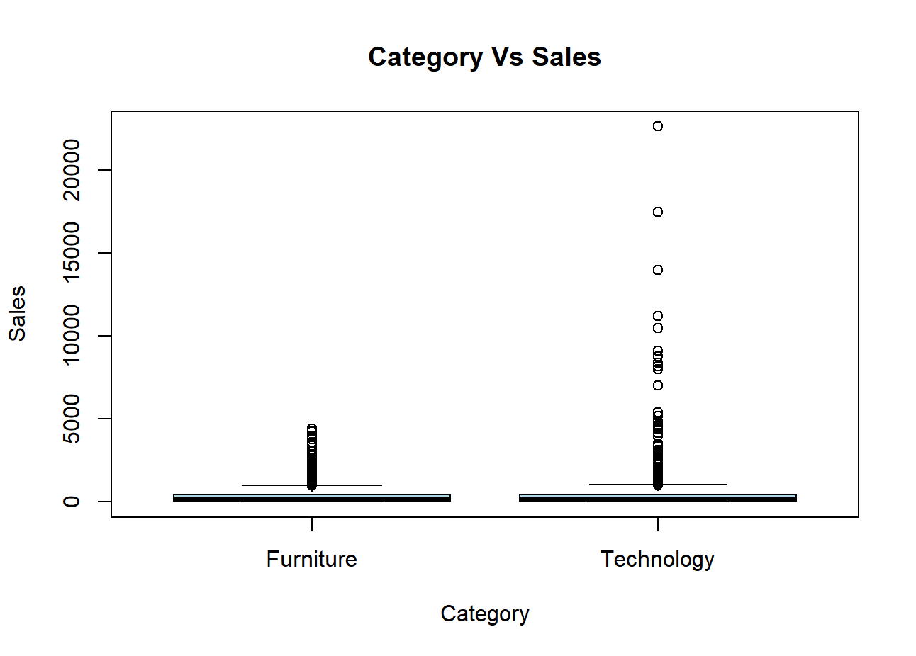
This indicates a high number of outliers. As such t test might not be the best option.

#t test
t.test(Sales ~ Category, data = d3, var.equal = TRUE)
Two Sample t-test

data: Sales by Category
t = -3.8902, df = 3889, p-value = 0.0001018
alternative hypothesis: true difference in means between group Furniture and group Technology is not equal to 0
95 percent confidence interval:
-159.04251 -52.45285
sample estimates:
mean in group Furniture mean in group Technology
350.6538 456.4015
Possibly being skewed by the very high outliers.
A Mann–Whitney U test was also sent for analysis
#wilcox test
wilcox.test(Sales ~ Category, data = d3, exact = FALSE)
Wilcoxon rank sum test with continuity correction

data: Sales by Category
W = 1799828, p-value = 0.01641
alternative hypothesis: true location shift is not equal to 0
Note the P value suggests that we should reject the null hypothesis.

For further analysis the outliers were removed at 1.5IQR
d4 <- d3 %>%
group_by(Category) %>%
filter(
Sales >= quantile(Sales, 0.25, na.rm = TRUE) - 1.5 * IQR(Sales, na.rm = TRUE),
Sales <= quantile(Sales, 0.75, na.rm = TRUE) + 1.5 * IQR(Sales, na.rm = TRUE)
) %>%
ungroup()

This reduced the data set to 3561 observations and 3 variables

table(d3$Category)
table(d4$Category)
Furniture Technology
2078 1813
> table(d4$Category)

Furniture Technology
1916 1645

Furniture -162 (8% approx)
Technology - 168 (9% approx)

The data was then checked for outliers
#check outliers
aggregate(Sales ~ Category, data = d4, summary)
Category Sales.Min. Sales.1st Qu. Sales.Median Sales.Mean Sales.3rd Qu. Sales.Max.
1 Furniture 1.8920 41.9600 152.7640 236.0063 350.0617 1013.8320
2 Technology 0.9900 59.9800 143.9280 235.0246 339.9600 1029.9500

Demonstrating a mean and median that are closer together.

#t test
t.test(Sales ~ Category, data = d4, var.equal = TRUE)

#wilcox test
wilcox.test(Sales ~ Category, data = d4, exact = FALSE)

Two Sample t-test

data: Sales by Category
t = 0.12272, df = 3559, p-value = 0.9023
alternative hypothesis: true difference in means between group Furniture and group Technology is not equal to 0
95 percent confidence interval:
-14.70187 16.66527
sample estimates:
mean in group Furniture mean in group Technology
236.0063 235.0246

Wilcoxon rank sum test with continuity correction

data: Sales by Category
W = 1522577, p-value = 0.08122
alternative hypothesis: true location shift is not equal to 0
With the removal of outliers the null hypothesis is no longer rejected.

Conclusion
There may be a slight difference between total sales of furniture and total sales of technology both between customers and in total number of sales.
However, statistical significance was only demonstrated when outliers are removed.

Conduct an independent t-test to assess if there is a significant difference in mean sales between Consumer and Corporate customer segments in the Superstore dataset.
H₀ Consumer = Corportate
H_{a} Consumer ≠ Corportate

To begin the data was simplified to only sales and segment catagories
library(readr)
library(dplyr)

train <- read_csv("seminar/train.csv")
View(train)

d1 <- train

#query segment
table(d1$Segment)

#simplify dataset
d2 <- train %>%
select(Segment, Sales)
Reducing the data to 9800 observations and 2 variables.

Next the Home office entries were removed.

#remove home office
d3 <- d2[d2$Segment != "Home Office", ]

#count
#!!! high disparity between number of purchases - might cause later issues
table(d3$Segment)

Consumer Corporate
5101 2953

Reducing the data to 8054 Observations and 2 variables.
It is worth noting that there were around 1.7 times as many consumers than corporate customers. This could potentially cause bias in the data.

The data was then observationally inspected

#inspect - highly right-skewed data!
consumer <- d3$Sales[d3$Segment == "Consumer"]
corporate <- d3$Sales[d3$Segment == "Corporate"]

plot(
density(consumer, na.rm = TRUE),
main = "Sales Density by Segment",
xlab = "Sales",
ylab = "Density",
col = "orange",
lwd = 2
)

lines(
density(corporate, na.rm = TRUE),
col = "blue",
lwd = 2
)

legend(
"topright",
legend = c("Consumer", "Corporate"),
col = c("orange", "blue"),
lwd = 2
)
#compare
by(d3$Sales,d3$Segment, summary)

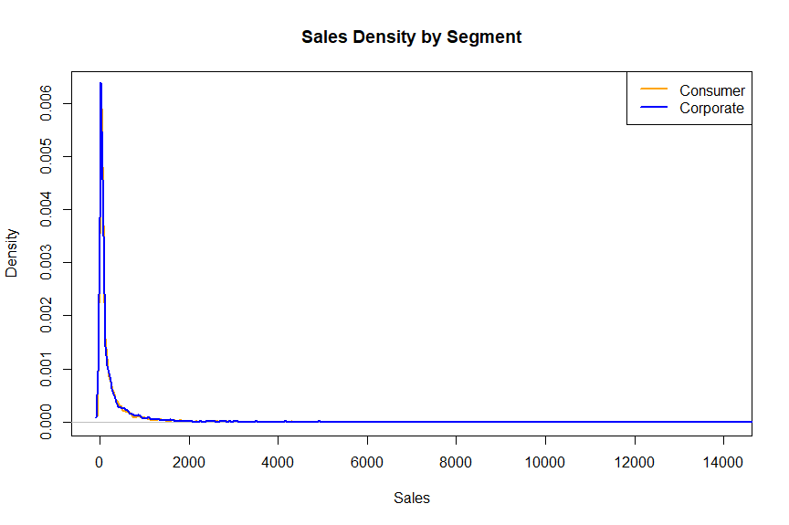
d3$Segment: Consumer
Min. 1st Qu. Median Mean 3rd Qu. Max.
0.444 17.280 53.982 225.066 208.560 13999.960

d3$Segment: Corporate
Min. 1st Qu. Median Mean 3rd Qu. Max.
0.556 17.380 56.300 233.151 213.080 17499.950

An additional test for variance was used as this could affect the t test calculation
#test for variance
var.test(
Sales ~ Segment,
data = d3
)
F test to compare two variances

data: Sales by Segment
F = 0.96309, num df = 5100, denom df = 2952, p-value = 0.2483
alternative hypothesis: true ratio of variances is not equal to 1
95 percent confidence interval:
0.9030351 1.0265778
sample estimates:
ratio of variances
0.9630946

These results suggest that there is no statistically significant variance between the two data sets.

The requested non-paired ttest was used
# nonpaired ttest with demonstrated same variance
t.test(
Sales ~ Segment,
data = d3,
var.equal = TRUE
)

data: Sales by Segment
t = -0.58957, df = 8052, p-value = 0.5555
alternative hypothesis: true difference in means between group Consumer and group Corporate is not equal to 0
95 percent confidence interval:
-34.96657 18.79669
sample estimates:
mean in group Consumer mean in group Corporate
225.0658 233.1507

The p result was high and thus we fail to reject the null hypothesis.

For comparison the Mann–Whitney U test:

wilcox.test(
Sales ~ Segment,
data = d3
)
Wilcoxon rank sum test with continuity correction

data: Sales by Segment
W = 7474249, p-value = 0.5683
alternative hypothesis: true location shift is not equal to 0

Again we fail to reject the null hypothesis.

Finally a random sample to match the total number of consumer and corporate:

#match sample sizes

# make the random sample reproducible
set.seed(123)

# number of Corporate rows
n_corporate <- sum(d3$Segment == "Corporate")

# randomly sample the same number of Consumer rows
consumer_sample <- d3[d3$Segment == "Consumer", ] |>
sample_n(n_corporate)

# keep all Corporate rows
corporate_data <- d3[d3$Segment == "Corporate", ]

# combine into new balanced dataset
d4 <- rbind(consumer_sample, corporate_data)

# check totals
table(d4$Segment)

#inspect

#compare
by(d4$Sales,d3$Segment, summary)

#test for variance
var.test(
Sales ~ Segment,
data = d3
)

# nonpaired ttest with demonstrated same variance
t.test(
Sales ~ Segment,
data = d4,
var.equal = TRUE
)

#for comparison a Mann–Whitney U test
wilcox.test(
Sales ~ Segment,
data = d4
)

No statistically significant difference was found to reject the null hypothesis. Indeed there was stronger evidence in favour of the null hypothesis.

Conclusion
There is low statistically significant evidence to suggest that there is a measurable difference between corporate and commercial spending.

References

Blonde_Pretzel (2018) Parametric Statistical Tests for Degree Level and A Level Psychology. Available at: https://www.tes.com/teaching-resource/parametric-statistical-tests-for-degree-level-and-a-level-psychology-11442435 (Accessed: 29 September 2026).

Soetewey, A. (2021) What statistical test should I do? Available at: https://statsandr.com/blog/what-statistical-test-should-i-do/ (Accessed: 29 September 2026).

